Submission Process
Lancaster Conference on Infant and Early Child Development
In the next lines we will walk you through the submission process. It is straightforward but we are pleased to help if you encounter problems. You can contact us at lcicd.enquiries@lancaster.ac.uk
When your abstract is completed and ready to send, visit the Lancaster Conference on Infant and Child Development website or directly follow this link to Submission. There, you can find important information as well as the path to the online abstract submission platform:
1) Create your EasyChair account (Only if you do not have one)
To create an account, you can either visit the Easy Chair website (https://easychair.org/account/signup) or click in the Lancaster Conference on Infant and Child Development (LCICD 2021) submission link:
You will be brought to a login page for the conference. To set up an account please select “sign up for an account”.
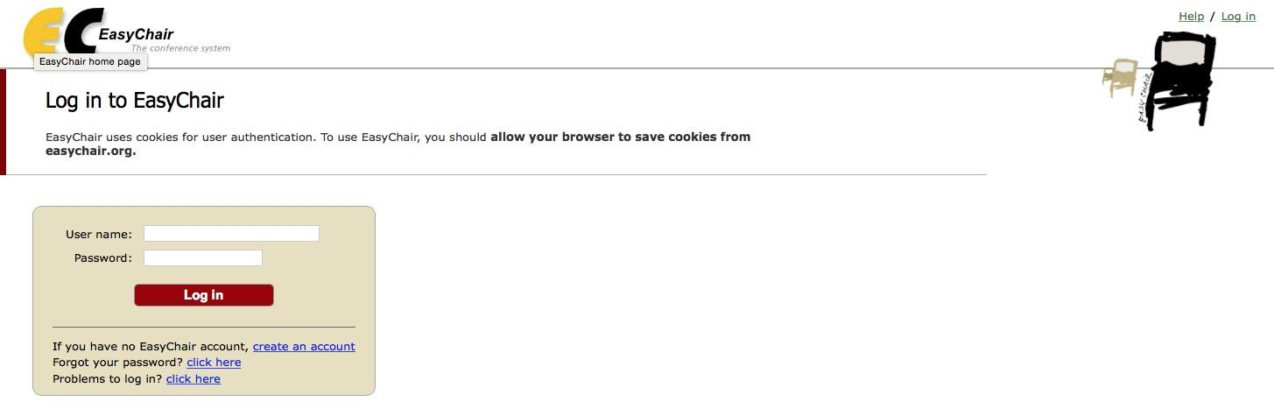

This will bring you to step 1 of the account request. Complete the image recognition test before creating an account.
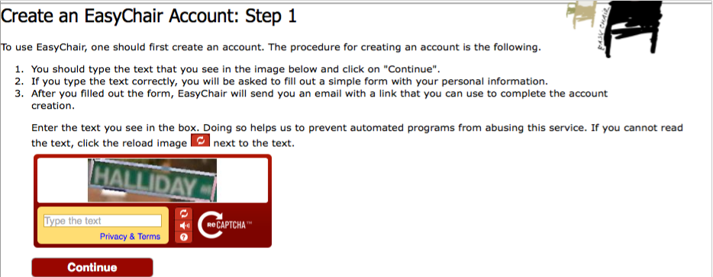
In step 2 you are requested to fill in personal information.
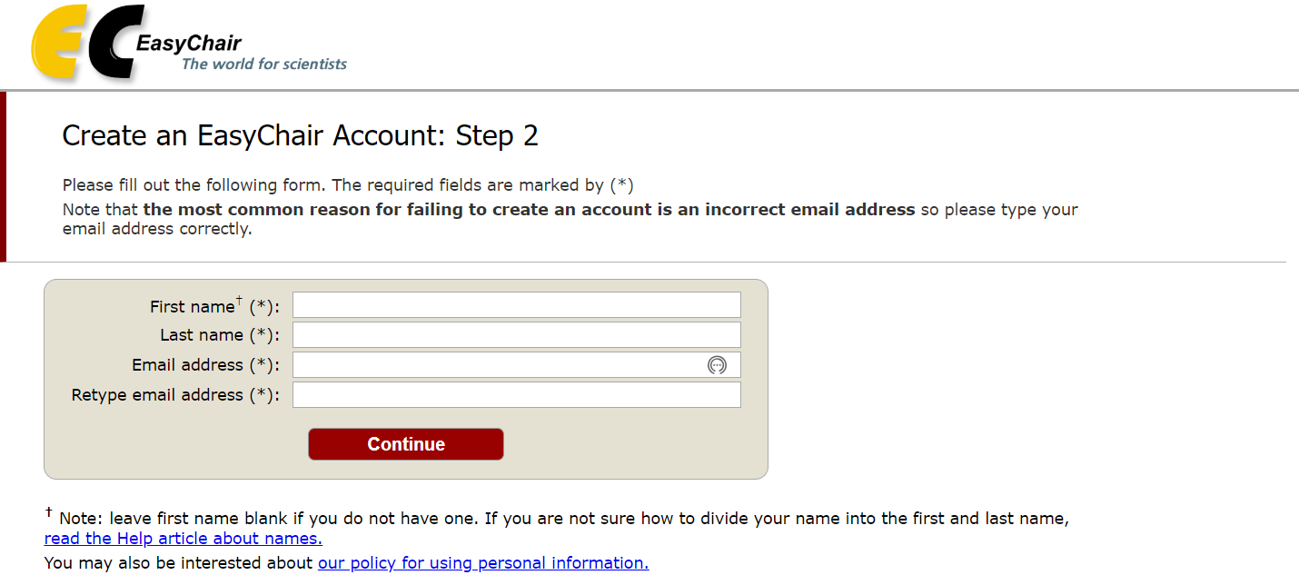

Next, you will be shown an acknowledgement and a list of instructions. Almost immediately you will receive an email to your account introduced in step 2. Please check your spam/junk folder if you do not receive an email from EasyChair. Click on the link to confirm and complete your account creation.
This will bring you to the last step; complete your registration by providing all required information. Then click “Create my account” and your account will be set up.

Last step:
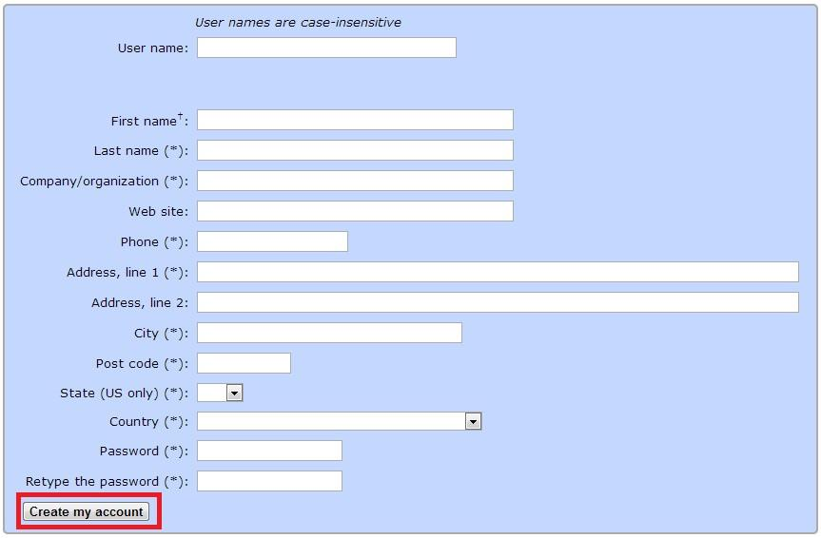

2) Your Abstract(s) Submission.
Do not forget to submit your abstracts before 23:59 pm (GMT), April 1, 2021. To submit your abstract, please click on the LCICD 2021 abstracts submission link and enter your EasyChair login information.
This link will bring you to your own online submissions panel for the Lancaster Conference on Infant and Child Development. Here you can manage all your submissions as well as follow the state of your submissions.
To make a submission, first click on “New Submission” button located in the top-left corner of the menu bar.

Then, you will be shown a list of fields to enter. At the beginning, you will find the author’s information. Fill out the required information for as many authors as you consider. This information will not be visible for the Program Committee.
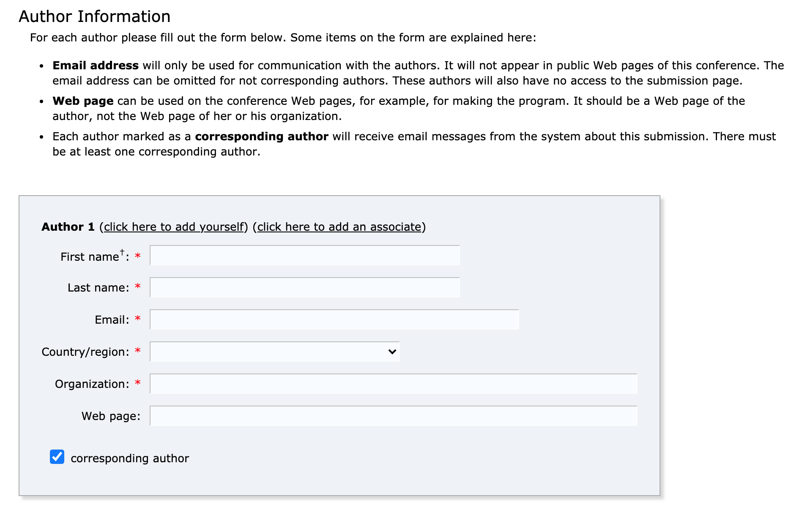

Below the author’s field, you will find the title and abstract boxes. Write in plain text (or copy and paste) the title of your abstract and the abstract. Remember that the abstract can have a maximum length of 300 words.
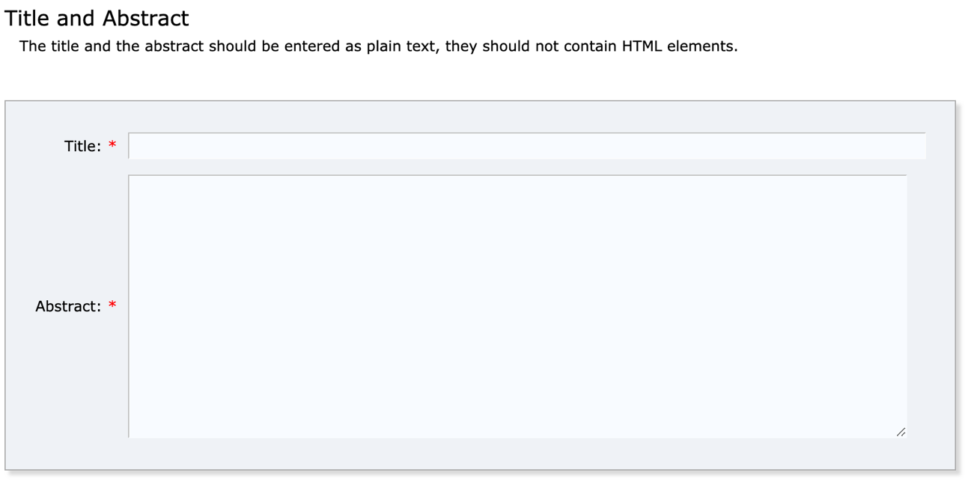
Afterwards, you will find a box, where you must write or paste at least three descriptive keywords of your submission.
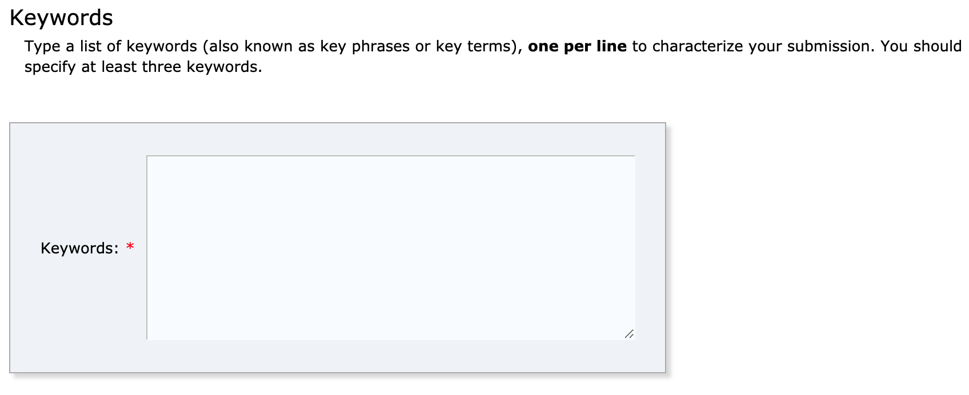

Using the drop-down menu, please indicate what you would like your abstract to be considered for: Oral presentation, poster presentation, or the early-career poster presentation.
Finally, click on “Submit” button once to submit your abstract
