Humphry Davy Worksheet

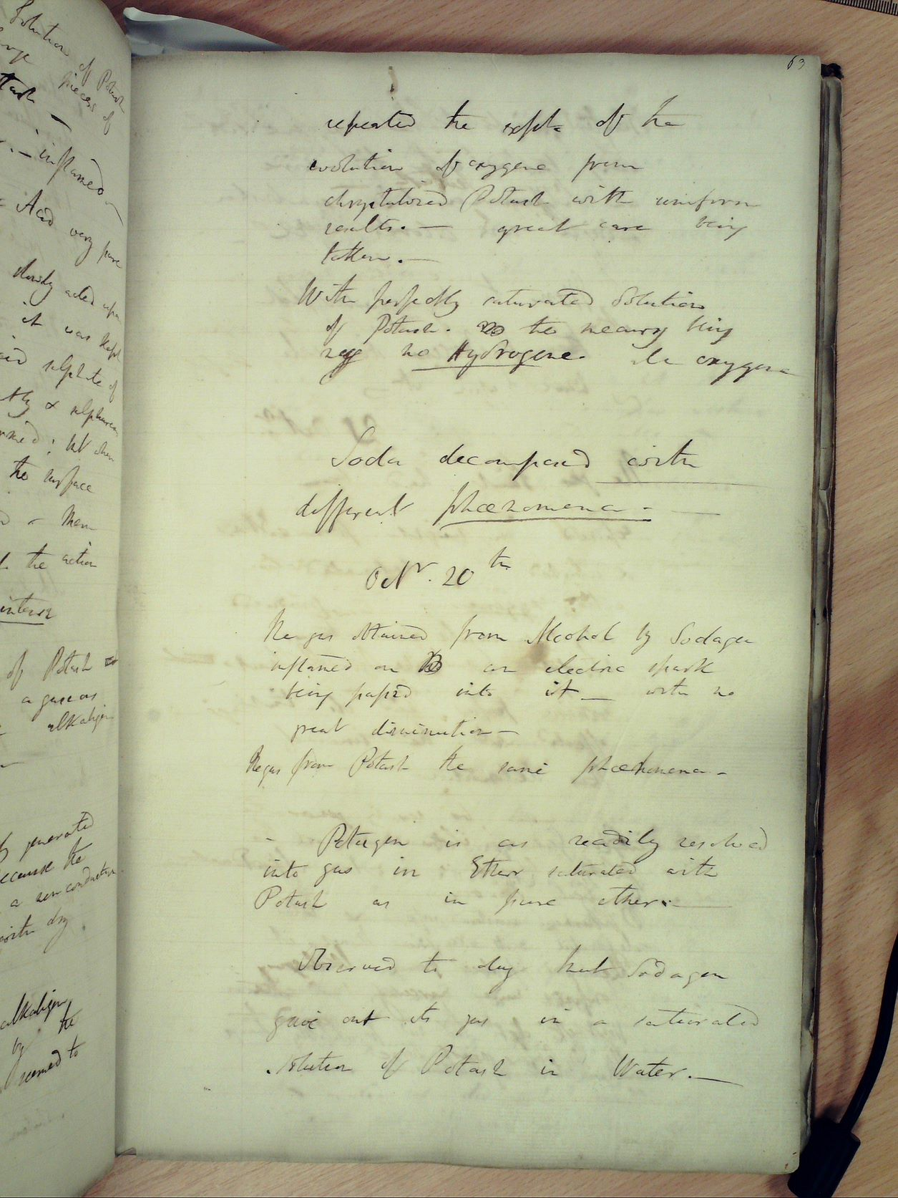

In pairs, discuss and answer the following questions using the information from the presentation and your own thoughts.

- Define the difference between a compound and an element.

- Why were some elements not discovered until Davy when others were known from the days of the ancient Greeks?

- Why would early modern scientists investigate different elements and identify them? Think of two reasons why the isolation of elements could be important.

- Using your knowledge of potassium and sodium, think about why the experiments were dangerous and if you should repeat the experiment what would you do to make it safer?

- Can you think of any uses to have a method to isolate potassium and sodium into their pure forms? – think about further chemical reactions

Humphry Davy’s notebooks are in the process of begin published and need a special front cover to complete the book. Design a colourful and decorative front page of these books complete with references to the work of Humphry Davy. Then write a paragraph about why it was designed this way (it should be around a half page to a full page)

Consider the information from the lesson today and other scientific contributions Davy made you can find.

These websites will be useful:

https://www.bbc.co.uk/history/historic_figures/davy_humphrey.shtml

https://www.britannica.com/summary/Sir-Humphry-Davy-Baronet

https://www.sciencehistory.org/historical-profile/humphry-davy

https://www.famousscientists.org/humphry-davy/

